2019 UOS-XMU SUMMER SCHOOL INTERNATIONAL

PROGRAMME OVERVIEW
The UOS-XMU summer school programme aims to provide aspiring students from University of Southampton (UOS) with abundant learning resources and cutting-edged knowledge about China’s economy, culture and other related academic areas, while promoting further development of the collaboration and exchange between the two universities.
This intensive two-week programme is designed for the students of the UOS who would like to learn more about Chinese economic concepts, developments and prospects in its social and cultural context. In order to create a visualized and dynamic environment for immersion study, the programme mainly consists of classroom lectures, field trips, culture experiences and workshop activities.
Lectures are designed to fully engage students by presenting interesting topics worthy of exploration and discussion, addressed by renowned scholars under each issue. To offer the students with “living textbooks”, a series of field trips are arranged for them to understand local industries and lifestyle, not only limited to the famous companies, historical sites and cultural attractions of Xiamen city, but also the one of the most important Chinese ports along ancient Maritime Silk road – Quanzhou.
In addition, cultural experience is a very important aspect of this programme. Students will have hands-on opportunities to be exposed with a fascinating mix of traditional Chinese culture, including Chinese tea, martial arts, Chinese painting and calligraphy and Chinese food. To promote people-to-people exchange, we will also organize workshop activities for UOS and XMU student to cooperate in group projects.
PROGRAMME DETAILS
- Date: 30 June -13 July, 2019 (14 Days)
- Eligibility: Students from the University of Southampton
- Must be 18 years old or over as of 30 June, 2019 and in good health
- Must be currently attending college/university
- Must attend all of the programme activities from 30 June -13 July, 2019 except under exceptional circumstances
- No particular knowledge background is required
- No Chinese language skill is required
- Language used: English
- Number of Participants: 20
- Site: Xiamen University Siming Campus (Xiamen)
As a special offer of the summer school of the UOS, the organizer will cover local hospitality, including meals, accommodation in Xiamen, some travel expenses for field trips, tuition fee, educational materials, welcome dinner, and course completion certificates.
The participants need to pay their own insurances, visa fees and travel expenses in and outside Xiamen as well as other personal expenses while in Xiamen.
SUPPLEMENTARY INFORMATION
Introduction to Xiamen City and Xiamen University
Located in the southeast coast of China, Xiamen is a seaside city with culture integrated both eastern and western features under the background of profound exchange and communication between Xiamen and abroad in recent years. Xiamen boasts charming coastline and multi-cultures of architecture and arts. Xiamen University (XMU) was founded in 1921 by Tan Kah Kee, the well-known patriotic overseas Chinese leader. Since its founding, inspired by its motto of “Pursue Excellence, Strive for Perfection,” XMU has accumulated rich experience and formulated its own characteristics in its operation, growing into a national key comprehensive university with a full range of disciplines, high-caliber faculty members and extensive international influence. With its attractive scenery, Xiamen University is recognized as one of the most beautiful universities in China. See the Website of Xiamen University: http://www.xmu.edu.cn/.

About Economics at Xiamen University

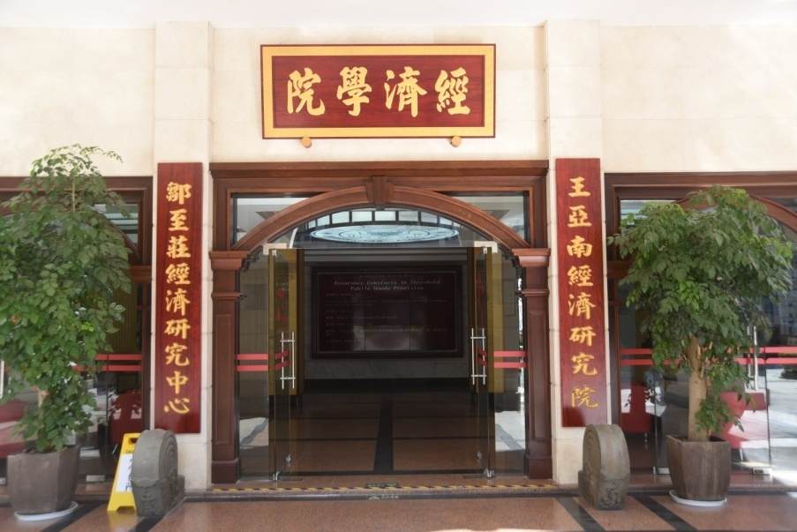
Welcome to the School of Economics (SOE), the Wang Yanan Institute for Studies in Economics (WISE) and the Gregory and Paula Chow Center for Economic Research (GCCER), at Xiamen University. As one of the top centers for teaching and research on economics and finance in the country, SOE/WISE/GCCER are privileged to welcome numerous domestic and international students and scholars each year.
A Glorious History
The Economics discipline in Xiamen University was first established in 1921 and has a long tradition of excellence in teaching and research. Mr. Wang Yanan, the former President of Xiamen University for 19 years and a renowned economist who translated Adam Smith's Wealth of Nations and Karl Marx's Das Kapital into Chinese, guided the rapid development of Economics in XMU in the early years of the university.

In September of 1981, China's Ministry of Education approved the elevation of the Department of Economics to the School of Economics （SOE）, making it the first school of economics established among top universities in mainland China. Ever since its establishment, the SOE has not only maintained its leading edge in economics research in China, but has also forged ahead towards its goal of being an internationally recognized center for teaching and research.

A Modern Research Institute

In 2005, economics research at Xiamen University received a huge boost with the establishment of the Wang Yanan Institute for Studies in Economics (WISE). WISE is a research-oriented institute founded as part of an initiative to modernize economics and finance research and education in China. WISE excels in econometrics, statistics, finance, experimental economics, law and economics and other fields of economics and business research. WISE focuses on frontier research, high-quality teaching, and enjoys intensive international academic exchanges and cooperation.
A World-Class Research Center
In 2016, world-renowned economist Professor Gregory Chow donated $10 million dollars for the establishment of the “Gregory Chow Economic Education Foundation” and the “Gregory and Paula Chow Center for Economic Research “at Xiamen University. The Chow Center is devoted to nurturing world-class economists and academic research, making itself the center of academic cooperation and communication not only in China, but throughout Asia and the world.
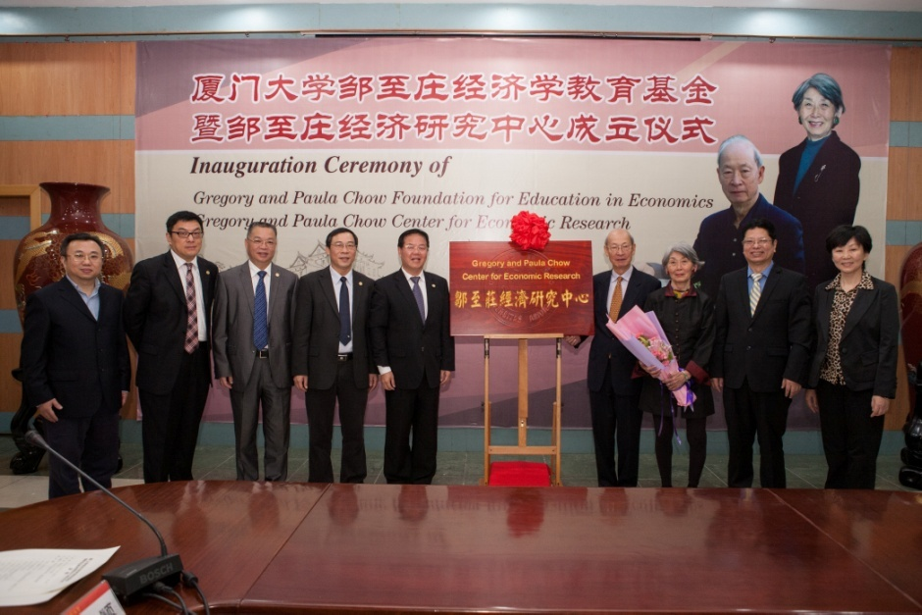
A Top Rate School in China and Asia

The SOE, WISE and the Chow Center are closely working together to promote Xiamen University as one of the major centers for economics and business research and education in the Asia Pacific region. In recent years, we have recruited faculty members from top universities, such as Columbia, Cornell, Harvard, London School of Economics, and New York University. Our colleagues have published articles in top journals in Economics, Business and Statistics, such as American Economic Review, Annals of Statistics, Econometrica, Journal of Financial Economics, Management Science, Quarterly Journal of Economics, Review of Economics and Statistics, Review of Financial Studies, and Strategic Management Journal.

The SOE, WISE and the Chow Center not only offer students rich courses on modern economics, and business taught by distinguished faculty, but also provide innovative programmes tailored to different career goals, excellent study abroad opportunities, sophisticated information technology services, and fascinating teaching and research experiences.

We invite you to learn more about us and to explore the various study opportunities available to you here. We also welcome comments or questions about our research or study programmes.

Please refer to the links below for more information.
WISE: http://wise.xmu.edu.cn/
GCCER: http://chowcenter.xmu.edu.cn/
SOE: http://soe.xmu.edu.cn/

Preliminary Schedule for Southampton-Xiamen Summer School 2019
30th June - 13th July
Date | Time | Activities | Notes | Fees
Sunday  30th June | TBC | Arrival at the airport
Sunday  30th June | TBC | Meet at the airport and transfer to the Caiqingjie Hotel | Bus to hotel, arranged by SOE
Monday  1th July | 09:00 -12:00 | Orientation & Campus Tour | Prof. Yinggang Zhou  N308 & campus
Monday  1th July | 12:00 – 14:00 | Lunch (on campus) | Accompanied by SOE and WISE students
Monday  1th July | 14:30 – 16:00 | Lecture 1: Labor Economics and China’s Growth Prospects | Prof. Lei Meng N308
Monday  1th July | 18:00 – 19:30 | Welcome dinner at local Chinese restaurant (Chinese art show before dinner) | Hosted by SOE  Restaurant (TBD)
Tuesday  2nd July | 08:30 -11:30 | Meet at the lobby and go for Chinese Cultural Experience 1: Martial Arts Workshop | Prof. Guangbo Yang (Venue TBC)
Tuesday  2nd July | 13:00 – 18:00 | Field Trip 1: Gulang Island Stroll | Accompanied by SOE and WISE students | Ferry fee 50RMB/person, pay in cash (recommended); tourist attractions tickets fee will be varying on the Island
Wednesday  3rd July | 10:00 – 11:30 | Lecture 2: Regional Disparity in China | Ms. Jing Zhang N308
Wednesday  3rd July | 14:30-17:30 | Chinese Cultural Experience 2:  Beijing Opera Appreciation and Facial Mask Making | Ms. Haitao Chen N308
Thursday  4th July | 08:30-10:00 | Lecture 3: Business Culture | Prof. Shaolian Liao  N308
Thursday  4th July | 10:10 – 12:00 | Field Trip 2: Local Enterprise Visit: Justsun Supply Chain Co. Ltd.
Thursday  4th July | 15:30 – 17:30 | Field Trip 3: Nanputuo Temple visit
Friday  ^{5th} July | 09:00 -10:30 | Lecture 4: Introduction to Experimental Economics | Prof. Seng Gen N308
Friday  ^{5th} July | 10:40 – 12:00 | Activity Workshop
Friday  ^{5th} July | 14:30-17:00 | Chinese Cultural Experience 3: Chinese Tea
Saturday  6th July | 08:30 -18:30 | Field Trip 4: Origin of Maritime Silk Road - Visiting Quanzhou | Arranged by travelling agency, accompanied by SOE and WISE students | 300RMB/Person, pay in cash (recommended) or credit card; fees are subject to change if the number of participants changes
Sunday  7th July |  | Free time
Monday  8th July | 09:00-10:30 | Lecture 5: Taking the pulse of the Chinese Economy | Prof. Cheryl Long N308
Monday  8th July | 13:00-14:00 | Teatime with SOE students Sunwise Café | Arranged by SOE  Sunwise Cafe
Monday  8th July | 14:30-17:30 | Field Trip 5: Zengcuoan visit and Island Ring Road Riding | Accompanied by SOE and WISE students
Tuesday  9th July | 09:00-12:00 | Chinese Cultural Experience 4:  Chinese Painting and Calligraphy | Ms. Haitao Cheng N308
Tuesday  9th July | 14:30 – 17:00 | Field Trip 6: Local Enterprise Visit | Arranged by SOE
Wednesday 10th July | 08:30 -18:30 | Field Trip 7: Meet at the lobby and go for Earth Towers of Hakka Day Trip | Arranged by travelling agency, accompanied by SOE and WISE students | 450RMB/Person, pay in cash (recommended) or credit card; fees are subject to change if the number of participants changes
Thursday 11th July | 09:00 – 10:30 | Lecture 6: Trade Liberalization and China's Economic Growth | Prof. Luhang Wang N308
Thursday 11th July | 10:40 – 12:00 | Preparing Presentation
Thursday 11th July | 15:00 – 17:30 | Chinese Cultural Experience 5: Making Chinese dumplings
Friday  12th July | 09:00-12:00 | Presentations | UOS & XMU students
Friday  12th July | 14:30-18:00 | Free time
Saturday  13th July | TBC | Meeting at the lobby, departing for London, transfer to the airport | Bus to the airport, arranged by SOE

